

Panel Data Homework

Author:
Lorenzo Alessandro Uberti Bona Blotto -- Student ID: 12419362 – M2 Financial Economics - QEM

Full Code and Datasets Repository Available at:
https://github.com/LorenzoAlessandro/Panel-Data-Project-Financial-Econometrics

Table of Contents
Part 0: Construction of the DATA frame to mimic the Paper 2
PART 1: data set, univariate and bivariate descriptive statistics after transformations 8
Question 1 8
Question 2 8
Question 3 9
Question 4 9
Question 5 12
Question 6 15
Question 7 15
Question 8 17
Question 9 17
Question 10 17
Question 11 18
Question 12 18
Question 13 18
Question 14 18
Question 15 18
Question 16 18
Question 17 18
Question 18 18
Question 19 19
PART 2: Classic benchmark multivariate panel data estimators 19
Question 20 19
Question 21 19
PART 3: Open section 20
Question 22 20
PART 4: To do list 20
Question 23 20
PART 5: Translation of code. 20

Part 0: Construction of the DATA frame to mimic the Paper

I made this section to describe how I accurately replicated the dataset presented in the paper to account for all the missing information’s which I would have had following only the Global Macroeconomic Database (GMD) (Muller et al, 2025). I was fortunate enough to have a highly detailed section within my replication paper which outlined then entire data frame creation process and where possible I followed this outline closely.
The end goal was to accurately reproduce their sample data, variables and imputation strategies for a predetermined set of 16 countries, over the period from 1882 to 2020 and also a corresponding smaller sample for some variables as outlined in the paper (Bua K et al, 2025). The entire panel frame is constructed using several macroeconomic and financial historical databases in line with those used in the replication paper. The panel is built by combining several macroeconomic and financial historical databases. For each source, I harmonise country identifiers, restrict the time dimension, and implement the same country- and period-specific imputations as in the paper. Finally, I merge all series into a single country–year data frame and export it as <<final_panel_dataset.xlsx >> which can be found on my Github page utilising the in the cover page in the folder DATA.
Real GDP per capita was sourced from the Maddison Project Data (Bolt and Van Zanden, 2020). The paper reported that there was some missing data from Japan between the period of 1882 to 1884 The paper reports that for Japan, real GDP per capita is missing in 1882–1884 and that they back-fill these years using the 1885 level of real GDP and historical population data. I replicated this exact strategy in my code. This allowed me to yield a complete data frame for real GDP per Capita series for all the target countries.
Labour Productivity was obtained from the long term productivity database (Bergaud et al, 2016). I had to re-formalise the table as it was originally in a long format and then map the countries consistent with the project countries, the sample was then restricted to the required pre-established time from spanning from 1882 to 2020. Which allowed me to yield a full data frame as in the replication paper.
Consumer Price Index data was taken from the JST Macrohistory Database ( Jordá et al 2017) and missing data was filled in using the pre-assigned GMD database. This data was harmonised for each target country. The paper states that the CPI panel is available for the full 16-country sample from 1882 to 2020. In my implementation, the only notable discrepancy concerns Ireland, for which the underlying JST file lacks observations between 1882 and 1921, making linear interpolation impossible due to the absence of endpoints. This is documented in my code comments.
The Trade Openness variable is defined i line with current economic theory in the paper as the sum of exports and imports over GDP. The primary source is again the JST Macrohistory Database, complemented by the Global Macro Database (GMD) and historical trade series as in the paper. The paper highlighted data discrepancies and I accounted for this by supplemented the baseline Jordà–Schularick–Taylor trade series with historical imports and exports data from Federico and Tena-Junguito (2016). In practice, this allowed me to fill missing observations for Australia (1914), Switzerland (1882–1884), and Germany (1914–1923) and in cases where the Jordà–Schularick–Taylor Macrohistory Database reported imports and exports but did not provide the corresponding nominal GDP series, I supplemented the missing GDP values using nominal GDP from the Global Macro Database (Müller et al., 2025). This was necessary for the Netherlands (1914 to 1920, 1940 to 1943) and Norway (1940 to 1945). For several countries whose wartime data were entirely missing (Germany (1944 to 1947), Japan (1944 to 1945), and the Netherlands (1944 to1945) I reconstructed the missing observations by linearly interpolating the ratio of total trade (imports + exports) to nominal GDP, following the methodology described in the paper. After applying all historical supplements, reconstructions, and interpolations, I obtained a complete trade-openness series for all 16 countries over the full 1882–2020 sample period, exactly mirroring the coverage in the original study.
For the Liquid Liabilities ratio which was defined in the replication paper as M2 or M3 over nominal GDP, the data was taken again from the JST database and supplemented by other historical sources as exactly stated in the paper. For example, data for Germany between 1939 to 1944 was taken from the Ritschl Database ( Ritschl, 2014), in this case I need to overwrite the money stock using M2 estimates and reconstruct the M2 for 1944 by summing the demand, time, and saving deposits. Similar strategic data manipulation was applied to the missing data period for Spain during the civil war, where I used the Martin Aceña database ( Martin Aceña, 2018) which allowed me to consolidate the circulation in both political zones of M1 estimates to be in line with the pre and post war levels. Other data merging can be found in my GitHub code such as for France (1914 to 1919) using the Bordo Database (Bordo et al, 2003). Lastly, I conducted data interpolation for missing data periods for Japan (1945), Netherlands (1942 to 1944), Spain (1940) and Germany ( 1923 to 1924 and 1945 to 1947). This allowed me to almost replicate identical summary statistics which are presented in the replication paper as shown below:

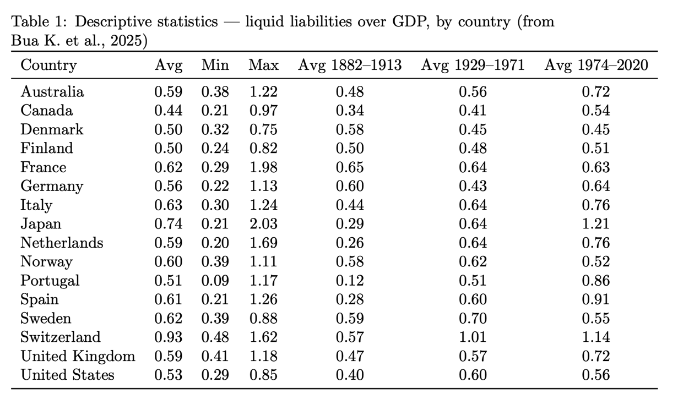

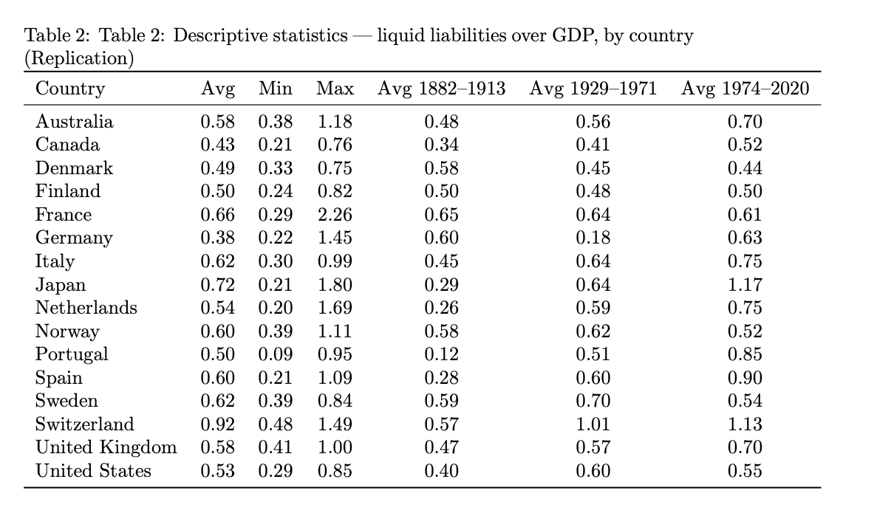
Stock Market Capitalization was defined as the stock market value over nominal GDP . The main source of data used was from the Zimmermann database (Kuvshinov et al, 2022). In this case in order to follow along with the paper I excluded Finland, Italy Japan, and the Netherlands due to data limitations and market closures. I then harmonised the year variable as an integer and cleaned to only have the target countries. To account for the small remaining gaps, I then interpolate the stock market capitalization ratio which in the end allowed me to create a fully balanced stock market capitalization series for 12 of the 16 countries from 1899 to 2016. The respective replication paper summary statistic table and my own are illustrated below:

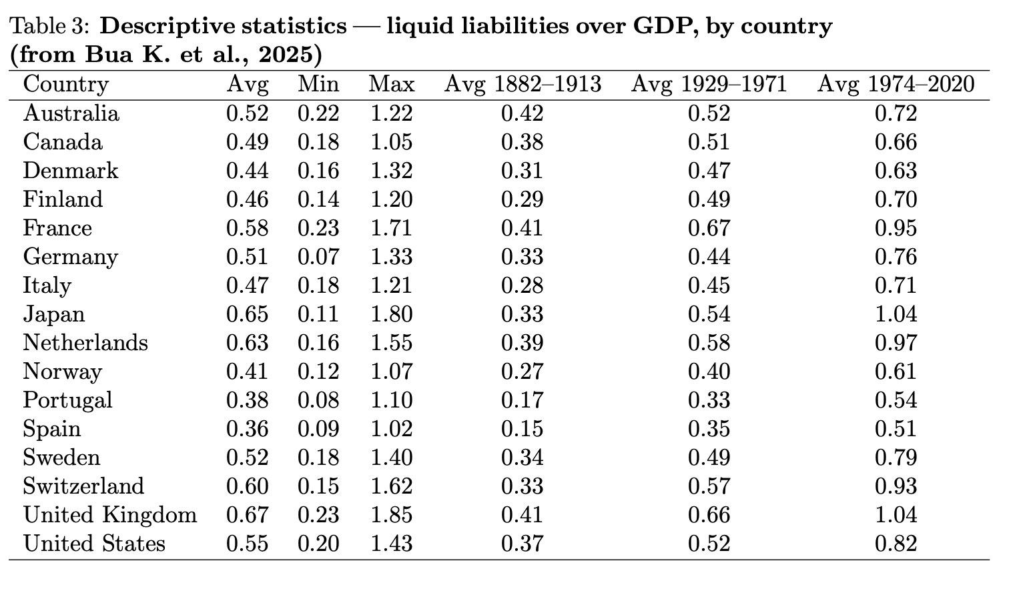

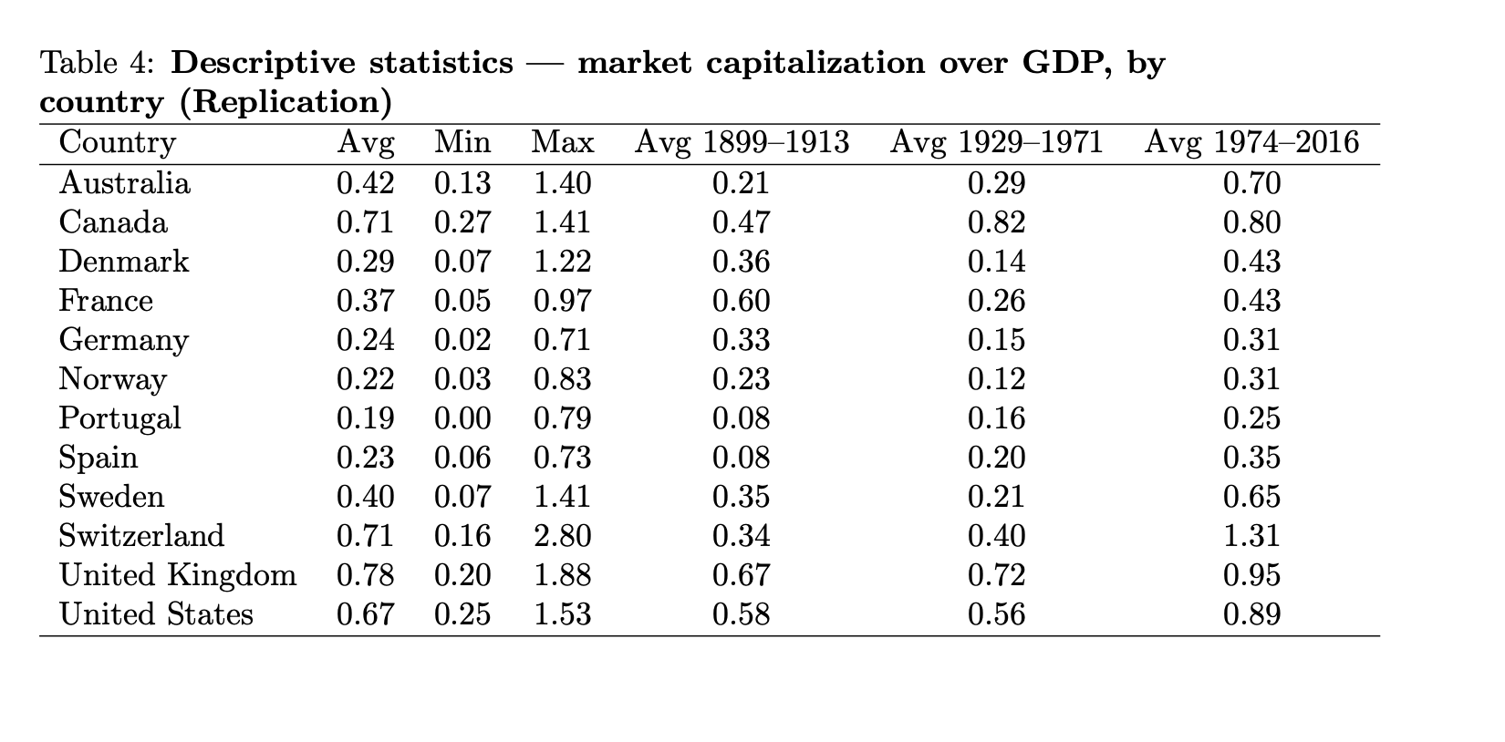
Important side note, my own data set for this variable doesn’t follow as closely that of the replication paper because there are some missing data observations for Australia, America, Canada and Spain which were missing even when I closely followed the methodology of the paper that weren’t retrievable as they started all from 1899 to – which made it impossible to interpolate as there was no starting observation. This explains the visible differences in the data.
Lastly, te bank loans variable as mentioned in the paper measures the total credit to private non-financial sector as a share of GDP. The construction closely follows that of the papers data methodology which uses a combination of the JST data set, the GMD (both previously used) and also the Global Credit project and world Bank data. The loan to GDP ratio was computed using the JST GDp whenever possible and if there were missing observations then it was replaced wth the GMD gdp figures. Again, following the paper methodology, the countries Spain, France, Netherlands and Portugal were excluded from the data frame. The paper states that for Germany (1921–1923, 1941–1945) and Japan (1945), the loan-to-GDP ratio is linearly interpolated. I also follow this logic for Australia 1946–1947, where the level of loans is taken from the Global Credit Project, and for Norway 1940–1945 (using GMD). For Japan, the paper uses World Bank series for domestic credit to the private sector by banks as a share of GDP in the final years of the sample. I replicate this by inserting the World Bank ratios (converted from percentages) into the corresponding years. This yields a bank-loan-to-GDP series for 12 countries from 1882 to 2020, in line with the sample described in the paper with the respective descriptive statistics shown below:

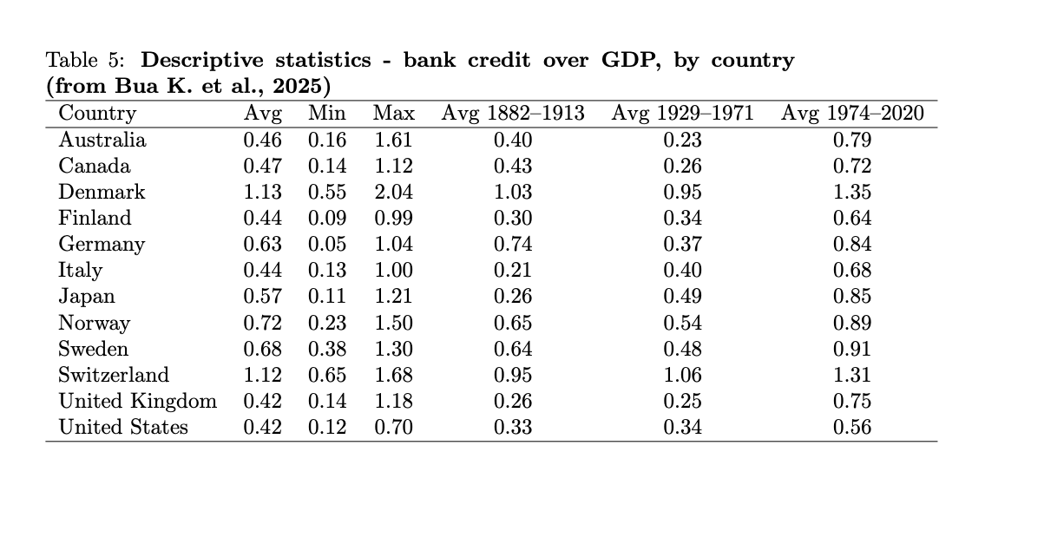

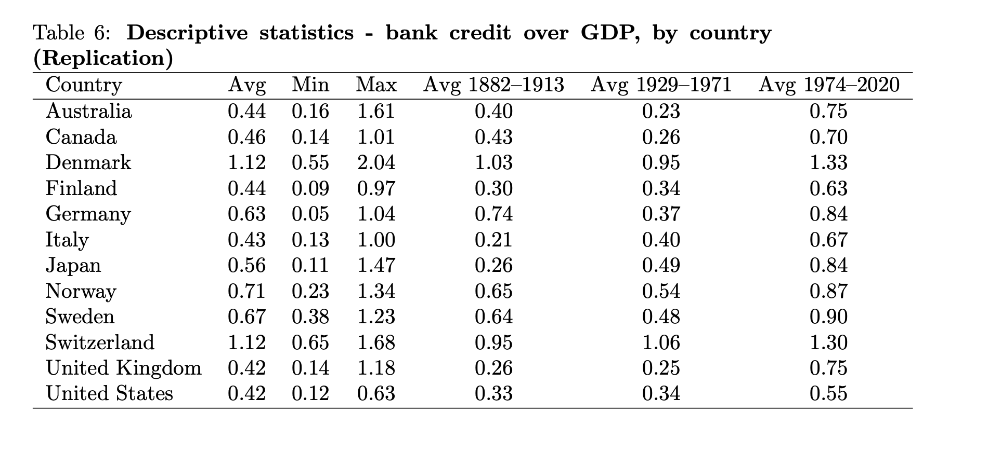
As we can see these figure similarly to liquid liabilities follow much more closely the original data set implemented in the replication paper. Finaly to finish all these respective data series were then taken and merged together t form the final data set which as mentioned before can be found on my Github page.

PART 1: data set, univariate and bivariate descriptive statistics after transformations

Question 1
In your data set, which are the variables which are varying with respect to two indices (or more if you consider inflows and outflows from one individual or country to another individual or countries? Which are the variables which are varying only with respect to time? Which are the variables which are varying only with respect to individuals?

Question 2
What is the largest number of period T for individuals? What is the number of individuals (countries)?

The time frame is dependent on the data availability for different variables, the main bulk of the data frame series spans from 1882 to 2020, for 16 different advanced economies, this time span is covered by the variables with the longest historical availability (GDP per Capita, Trade Openness, Liquid Liabilities). Therefore, the theoretical size of the Panel Data frame 16 countries for 139 years. However, it is important to note that not all the variables span this time period or for all countries. The financial variables (one of the explanatory variables in this study) which are comprised of data on both stock market capitalizations and also banking data. These span the time period of 1899-2016 for market cap and for bank loan data through the use of linear interpolation they were able to attain a full spanning data set however both of these variables are only consistent with 12 of the 16 countries since they omitted 4 different countries for each variable as a result of data constraints. Therefore, to conclude the final data set spans 1882–2020 for the core 16-country macroeconomic variables, while two financial variables, stock market capitalization and bank loans, have shorter time spans (1899 to 2016 and 1882 to 2020, respectively) and cover only 12 countries due to historical market closures or data unavailability.

Question 3
Comment on the structure of the unbalanced panel (how many (and which) countries have a single observation, discontinuities between observations, how many individuals have at least 2 consecutive observations (which is useful to compute lags, autocorrelations, first difference and within estimators)?

In my Github code I computed the number of observations for each country, if there was any discontinuity and also if there was at least one pair of consecutive observations which would be essential If I were to then go on and compute lags, first differences, autocorrelations and fixed effects. The results are shown below:

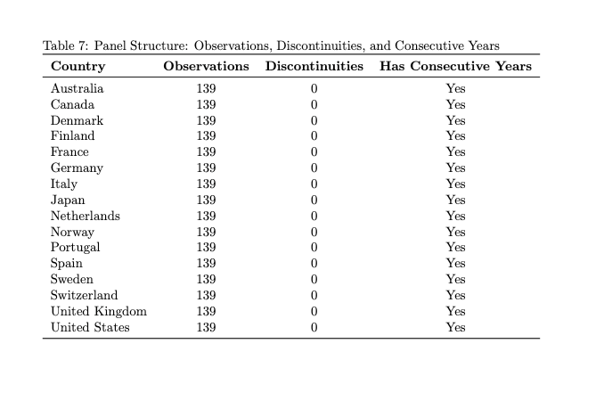
As we can see from Table 7 every country has the required 139 observations meaning they sapn all from 1882 to 2020 without missing years in the merged panel. This shows that my replication strategy allowed me to successfully harmonise all variables so that the merged data set is balance in the time dimension for all individuals. For each country I then went on to calculate the time discontinuity as:

$${discontinuity}_{i}=\#\{t:{year}_{t}​-{year}_{t-1}​>1\}$$

As we can see from the table that eery country has 0 discontinuities, this means that post merging all my singular time series variables into on final data set, each country has a perfectly continuous annual time series from 1882 to 2020. It is important to note that even for some variable’s there are gaps, but the final dataset has no breaks in the year index. And finally, every country from the 16 has at least 2 pairs of consecutive observations, in fact all countries have 138 pairs, this allows for the guarantee that if need be we can do , the computation of lags ($x_{i,t-1})$, first differences ${∆x}_{i,t}= x_{i,t}- x_{i,t-1}$, fixed effects and Autocorrelation measures.

Question 4
VARIABLE TRANSFORMATIONS PART 1: Compute between transformed and one-way-within transformed variables for all variables. Present a table with the the variance of the one-way-within-fixed-effects, between and pooled data for each variable. Compute the share of between and within variance in the total variance for each variable. Comment these results.

In panel data, the necessity of understanding how each variables variation of time evolves for each individual is highly important since these results help to choose the appropriate econometric testing model and also allow for better interpretation of results estimates. Before estimating fixed-effects or random-effects specifications, it is standard practice to decompose the total variance of each variable into its between-country and within-country components. This decomposition allows us to determine whether a variable is primarily driven by cross-sectional differences, such as long-run structural characteristics of countries, or by time-series dynamics, such as business-cycle movements, financial fluctuations, or policy shocks. The between transformation originates from early variance-components work by Balestra & Nerlove (1966) and Swamy & Arora (1972), and was fully formalised and popularised in panel-data econometrics by Maddala, Hsiao, and Baltagi. The mathematical formulation of between transforms is illustrated below:

$$\overline{x_{i}}≡ \frac{1}{T_{i}}\sum_{t}{x_{i,t}}, where the between transformed variables is, x_{i,t}^{B}= \overline{x_{i}}$$
On the other hand, the within transformed variables is a way to remove all cross-sectional differences and is also mathematically formulated as $x_{i,t}^{W}= x_{i,t}-\overline{x_{i}}$ and therefore logically the within variance is simply: ${VAR}^{W}=Var(x_{i,t}-\overline{x_{i}})$. I computed the variance of the pooled, between, and within components for each macroeconomic and financial series and expressed both between and within variances as shares of the total pooled variance. This is all shown in the table below:
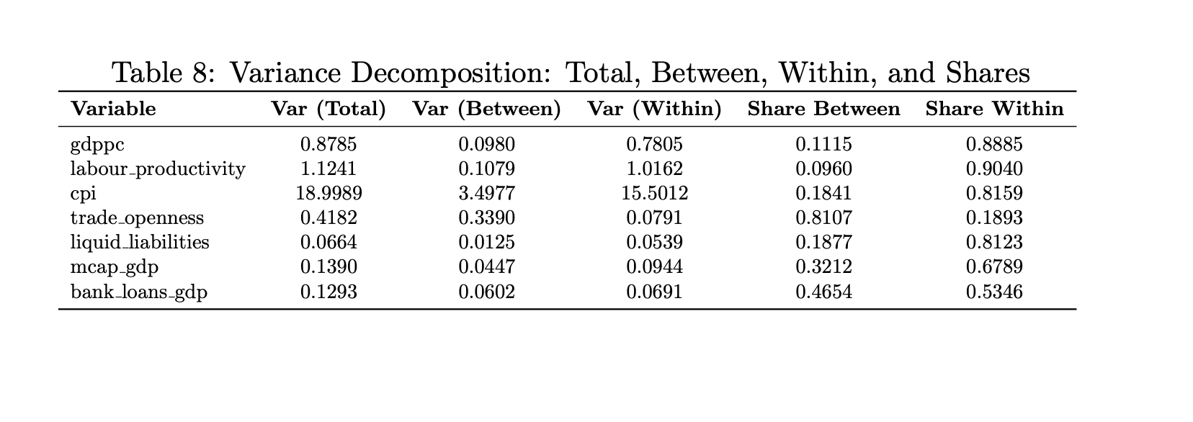
Following the computation of the three respective variance components we can clearly see that there is a clear distinction between the different macroeconomics variables in the sense of how they vary in the panel frame. Important side note is that prior to the computation in order to remain in line with my papers literature and not get blown out of proportion results I decided to log GDP, labour productivity (growth proxy – stubbornness variables instead of GDP) and CPI), this was done in order to reduce the potential skewness and absolute ranges in order to have percentage based, scale free measures. The og transform therefore can be said to equilibrise variance, reduce influence which stabilises variance, reduces the influence of extreme values, and makes the between/within decomposition more interpretable. After the transformation, the between and within components were computed using the same formulas as before:
$${VAR}^{T}= {VAR}^{B}+ {VAR}^{W}$$
$${Share}^{Between}= \frac{{VAR}^{B}}{{VAR}^{T}}, and, {Share}^{Within}= \frac{{VAR}^{W}}{{VAR}^{T}},$$
The following decompositions allows for interpretable insights on whether each variable dominated by cross country structural differences or by within country structural differences. For the Logged components, i.e. Log GDP, Log Labour Productivity, Log CPI the variables display a high level of within country variance shares, which range from around 0.82 to 0.90, this shows how impactful the time variation component is on these respective series intercountry. For log GDP per capita (within share: 0.8885) and log labour productivity (0.9040), the overwhelming share of variation arises from how individual countries evolve over time. This reflects the strong economic growth patterns, productivity improvements, and cyclical dynamics that many European economies experienced over the sample period. CPI also follows this pattern of having a high within VAR as mentioned before but this is attributed to other reasons, since inflation can be said to be a consistently time driven component in general due to it being shaped my macroeconomic and monetary conditions Aswell as external shocks. These results confirm that these logged macroeconomic variables are largely dominated by intertemporal economic developments rather than stable differences in cross-country levels.
Financial Development indicators such as the liquid liabilities, market capitalisation to GDP, and bank loans to GDP exhibit a more balanced variance structure. Liquid liabilities have a strong within country VAR (0.81) which could be an indicting of stronger domestic financial deepening Aswell as credit cycles evolve overtime in each economy. Market capitalisation to GDP has a moderate between share (0.3212), reflecting structural differences in financial systems, most likely because of bank-based versus market-based financing, combined with substantial time variation related to asset-price cycles and market volatility. Bank loans to GDP is the most balanced variable, with almost equal contributions from between-country (0.4654) and within-country (0.5346) components. This pattern suggests that while certain countries exhibit persistently larger banking sectors, credit cycles and lending trends also fluctuate strongly over time. The mixed structure of these variables indicates that both country-specific heterogeneity and dynamic financial movements are empirically relevant.
Lastly Trade Openness is the clearest example of a variable dominated by between-country variation (0.8107), with only a limited share of within-country variation (0.1893). This is economically intuitive: the degree of trade openness is largely determined by long-run structural factors such as geography, economic size, industrial composition, and institutional integration (e.g. EU membership). These characteristics remain relatively stable over time, leading to strong cross-sectional differences but limited intertemporal movement. As a result, most of the total variability in trade openness reflects persistent differences across countries rather than short-run fluctuations.

Question 5
Plot the distribution of the one-way-fixed-effects-within x(it)-x(i.) and between (x(i.)) transformed dependent variable and of you key (preferred) explanatory variable (not all the explanatory variable) plotting on the same graph an histogram, a normal law with same empirical mean and standard error and a kernel continuous approximation. Comment the between and within difference for each variable, and compare within/within for dependent and explanatory variable, and between/between for dependent and explanatory variable: kurtosis, skewness, non-normality, high leverage observation (far from the mean), several modes (mixture of distribution)?

To keep in-line with the replication paper and to ensure consistency in the empirical strategy which Bau et al (2025) used I constructed the dependent and explanatory variables using the same methodology. The main empirical model which they use in the paper is a long-run panel data regression focusses on the finance and growth of advanced economies, the regression model is shown below:

$${Growth}_{i,t}= α_{i }+ γ_{t}+ β_{1}\ln\left({Growth}_{i,t-5}\right)+ + β_{2}{Finance}_{i,t}+ θX_{i,t}+ ε_{i,t}$$

Where:
${Growth}_{i,t}= ∆_{5}​ln({GDPpc}_{it})$ is the 5-year log difference of GDP per capita
$α_{i }$are the country fixed effects
$γ_{t}$ are the period fixed effects
$\ln\left({Growth}_{i,t-5}\right)$ is the 5-year lagged level of GDP per capita to control for convergence dynamics
$β_{2}{Finance}_{i,t}$ is the financial development indicator composed of ( Liquid Liabilities = $\frac{{M2/M3}_{i,t}}{{GDP}_{i,t}}$, Market Capitalization = $\frac{{Stock Market Capitalization}_{i,t}}{{GDP}_{i,t}}$ and Bank Credit to the Private Sector = $\frac{{Bank Credit to Private Sector}_{i,t}}{{GDP}_{i,t}}$)
$X_{i,t}$ = $\left[\begin{matrix}ln⁡(\frac{{Exports}_{i,t}+ {Imports}_{i,t}}{{GDP}_{i,t}}) \\ {CPI}_{i,t}\end{matrix}\right]$ is the P × 1 vector that includes two control variables (i.e., P = 2) composed of trade openness and inflation.
$ε_{i,t}$ is the error term.

The model employs logs as mentioned before to level (GDP, inflation and trade Openness) into percentage units, while also allows the growth rate to be transformed into log differences, which wo as an approximation for continuous percentage changes. This in turn allows coefficients for growth to be interpreted as elasticities. The financial variables aren’t logged as they are already bounded below by 0 and hance can take values very close to 0 letting them have already meaningful interpretations as linear proportions, in this case taking the log would only lead to undefined values or create distortive features. The non-logging of financial indicators falls in line with the general literature on the subject matter with prominent examples being the papers by King & Levine (1993), Beck et al (2000), Arcand et al (2015).

After having constructed the raw variables, I computed the within and between transformations using these 4 variables I then plot their respective histograms and overlay both a Gaussian kernel density estimate (KDE) and a normal density with the same empirical mean and standard deviation as the data. The summary statistics and respective plots are illustrated below:

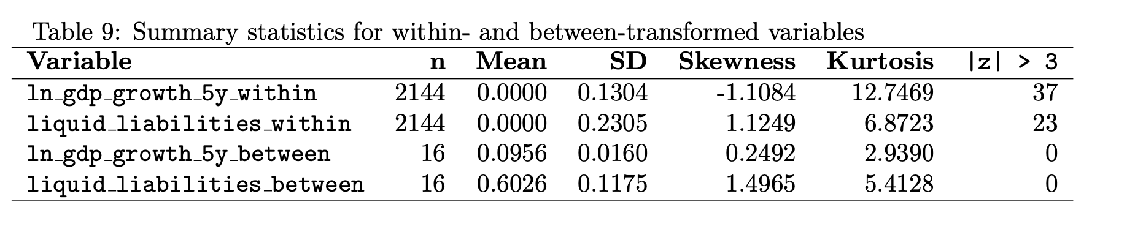

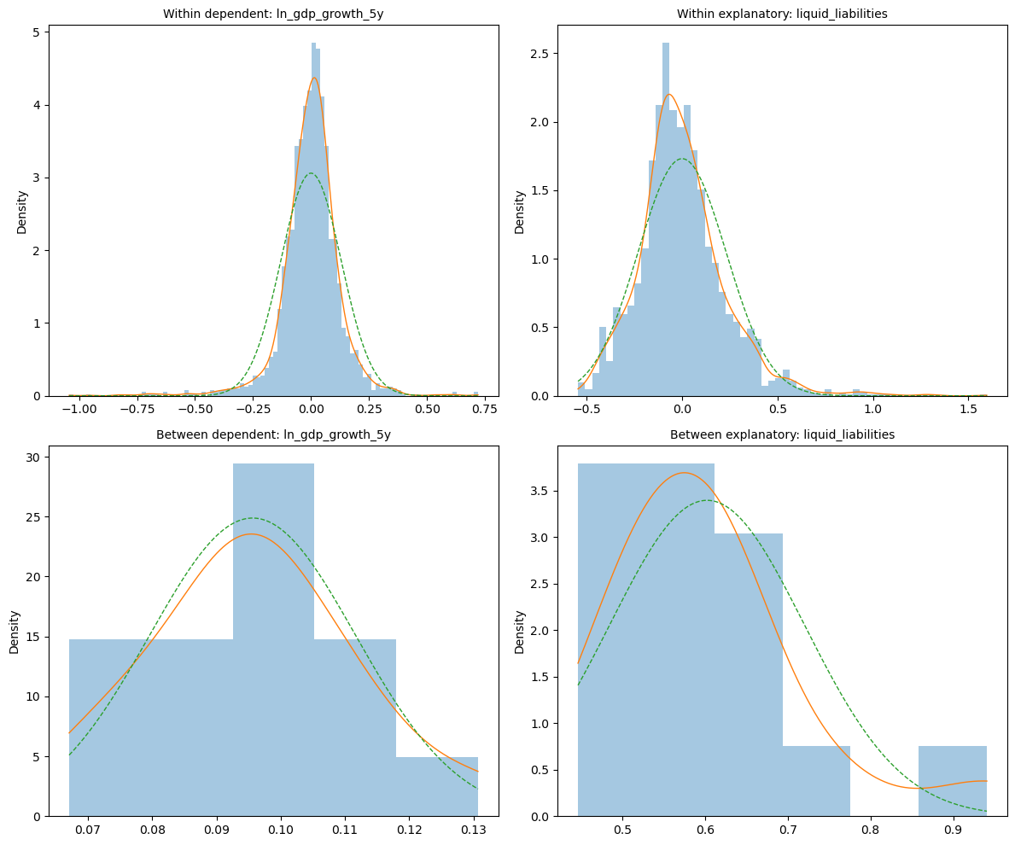

Within for the dependent variable which is the $∆_{5}​ln({GDPpc}_{it})$ by construction it has a mean zero; the standard deviation of 0.13 can be said to be rather sizeable and it implies that there is substantial volatility of medium run growth within countries. The skewness of -1.11 indicates that there is a longer left tail with the presence of greater and larger negative deviations from the country mean than positive ones. However, this is expected since its consistent with the notion that recessions occur less frequently than boom periods. The kurtosis statistic is extremely high compared to the 3 benchmark which indicates fat tails and high non-normality in distribution. I decided to include within the summary statistics a measurement for high leverage which records when the standard deviation of observation is larger than 3 to highlight (in this case) the prevenance of severe crises and exceptional booms. We can visually observe most likely where these high leverage period would have been which would have lead to these 37 obvs to be flagged up, from the figure illustrating the respective time series for each variable. The main time period which would contain these observations would be during the great depression ( around 1929- 1930), War time Europe ( 1914- 1918 and 1939-1945) and also the 2008 financial crisis. Visually the distribution is unimodal (singular peak) but still skewed to the left and heavy tailed.

The between for $∆_{5}​ln({GDPpc}_{it})$ has this appearance visually within the histogram due to there being only 16 observations, (I tried to change the bin number but ended up assign the bin = ‘auto’ code to find the most valid bin number). The mean growth rate between countries is circa to 9.6% over the 5 years. Standard deviation figures are small (0.016) which shows that the differences in average growth rates between countries are relatively modest relative to time variation, this can be visually checks and holds when we look at the time series as most countries tend to follow the same boom and through cycles. Skewness and Kurtosis are both close to the normal benchmark (0.25 and 2.94) showing the KDE and histogram are almost symmetric and close to a normal distribution. There are no high-leverage countries, and the small sample size means the histogram is naturally “blocky”, but there is no sign of multimodality.

Now moving on to within for the chosen explanatory variable which is liquid liabilities. As mentioned before by construction the mean is 0 and the within standard deviation is (0.23) which is larger than that of growth, showing sizeable within country movements in financial depth. Skewness is highly positive (1.12) with its histogram showing a strong right tail, hence more large positive deviations than negative ones. Intuitively this could be down to credit surges or booms which cause a deviation from the country specific norm. Kurtosis is also very high (not as much as growth) which give a leptokurtic characteristic to the distribution hence there is more mass in the centre and in the tails than a normal. 23 observations exceed |z| > 3, so there are many high-leverage within financial episodes, though somewhat fewer than for growth and lastly the distribution appears unimodal but clearly skewed and heavy-tailed: no strong evidence of multiple modes.

The between liquid liabilities exhibit a standard deviation of (0.12) which is non-negligible compared to the within std, countries differ quite a lot in their average level of financial depth, as expected (e.g. bank-based vs shallow systems). We can also observe that the skewness is also highly positive (1.5) and kurtosis also has an elevated figure compared the benchmark, again implying distribution of country means is right skewed with moderately fat tails. A few countries have persistently higher financial depth than the rest. Even so, with only 16 observations no country crosses the |z|>3 threshold; we have no statistical outliers, just an asymmetric upper tail. The histogram and KDE suggest a single peak with a long right tail rather than clear multi-modality

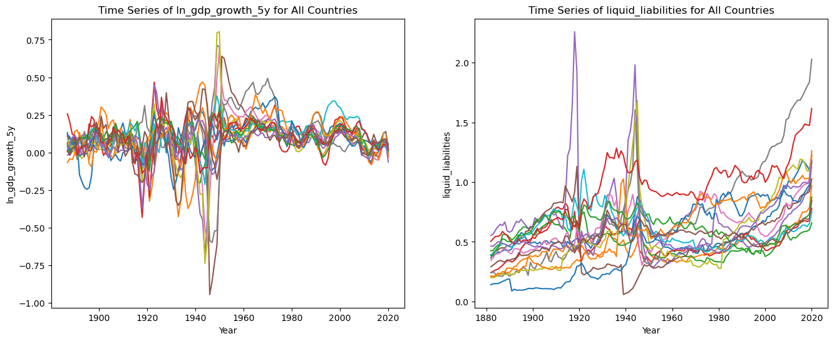

Question 6
FD. FIRST DIFFERENCE VARIABLE TRANSFORMATIONS: Compute the first-differences x(i,t)-x(i,t-1) for panel data. Check for the first 3 changes of individuals (for data sorted by individual and then time) in say 3T+1 first observations that when there is a change of individual in the stacked vector individuals x time, the first differences is a dot for “not available”. In other words, for first-differences for panel data, check that when you change individual, the first observation is missing with a dot, and it is not the difference of the first observation of the second individual minus the last observation of the first individual, for example.

Before computing my first difference I again restricted my original data frame to the key dependent and explanatory variables within my study, I decided to omit doing the first differences for my control variables. I then sorted each ‘relevant’ varible bout country and by time so that I could effectively check the 3T+1 observations. First differences were computed as:

$$∆x_{i,t}= x_{i,t}- x_{i,t-1}$$

I ensured this was kept solely within country using a group wise differencing procedure, I order to avoid the error of computing differences using observations for to different countries. I chose to verify this by applied a boundary check which would examine the first T observations and then subsequently the T+1 observation. Within this block, I identified the first three transitions between countries (i.e., the first three points at which the individual index changes in the stacked vector). At the boundary I ensured that the T+1 observation was in fact a missing value (NaN) in order to confirm that my differencing was successful. The check passed for all variables. At each of the first three country transitions (Canada, Denmark, and Finland in the dataset), every first-difference variable was correctly recorded as missing. This verifies that the procedure respects the panel structure and that the first-difference transformations were implemented correctly. I have inserted below my python output as proof of having verified the check.
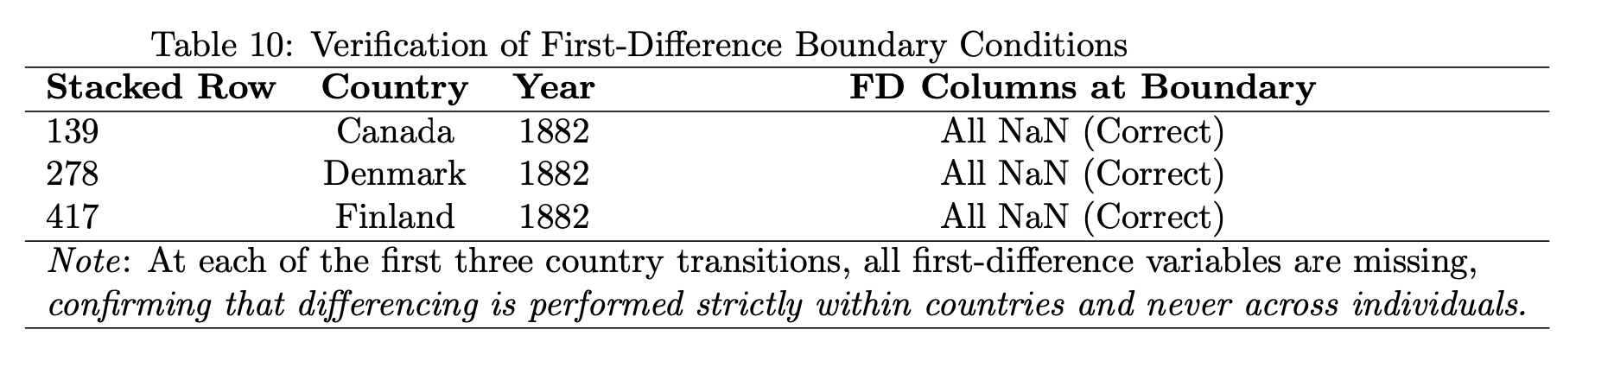

Question 7
First differences distributions. Plot the distributions (histogram, KDE, normal law with same mean and standard error) for first difference dependent ‘log GDP growth 5 yrs’ and first difference explanatory Liquid Liabilities for each of these two transformations.

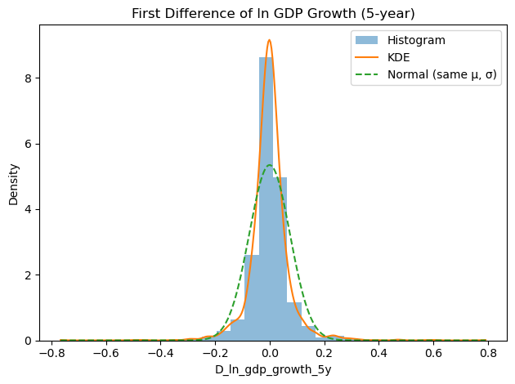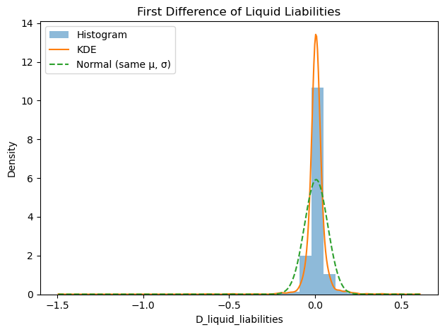

Question 8
First differences simple correlation. For these FD transformed variables, plot the bivariate cloud of points with regression line and on top the marginal distribution of the horizontal axis and on right hand side the marginal distribution of the variable on the vertical axis. Compare with one-way-fixed effects and between distributions. Report the simple correlation coefficient on the graph.

[ask elia for plot code]

Question 9
Restricted sample with a BALANCED PANEL: Two way fixed effects (TWFE) formula. Restrict the sample to the countries/individuals available with the longest duration (N=… countries over T=… periods). Compute -x(.t)+x(..), report the 6 numbers in a table as a function of time and plot them as a function of time, then comment. Then compute two-way-fixed-effects x(it)-x(i.)-x(.t)+x(..) transformed variables.

The use of two way fixed effect (TWFE) models was first theorised in early work by Balestra and Nerlove (1966), through their demonstration of how pooling cross-sectional and time-series observations allows researchers to decompose the error term into individual specific and time specific components. Their early work showed how unobserved heterogeneity can arise simultaneously across units and over time, and that failure to control for both dimensions leads to biased and inconsistent parameter estimates. These findings were further formalised into the contemporary econometric TWFE definitions which is presented by Woolridge (2010), the two-way fixed effects specification controls jointly for (i) unobserved, time-invariant individual characteristics and (ii) shocks common to all units in each time period. The standard TWFE model is written as:

$$y_{i,t}= α_{i}+ λ_{t}+ βX_{i,t}+ ε_{i,t}$$

This is then transformed as:

$$x_{i,t}^{TW FE}= x_{i,t}- x_{i,. }-x_{.,t }+x_{.,. }$$

Where:

$$x_{i,. }= \frac{1}{T}\sum_{t=1}^{T}{x_{i,t}} and x_{.,t }= \frac{1}{N} \sum_{i=1}^{N}{x_{i,t}} and x_{.,t }= \frac{1}{NT} \sum_{i=1}^{N}{\sum_{t=1}^{T}{x_{i,t}}}$$

The transformation above essentially removes all the individual averages $x_{i,. }$, time averages $x_{.,t }$and then after re adds back the overall mean $x_{.,. }$. The resulting transformed variable is essentially a double demeaned variable that isolates the joint within-unit and within-time variation. Applying this theory to the question, we hence apply this classical two-way fixed-effects transformation to variables from a balanced panel constructed using countries with the longest available time series. Since in the data cleaning stage all countries were set to have the same time frame, not a single one was dropped, therefore N = 16 and T =139 as before.

I computed the ${- x}_{.,t }+x_{.,. }$ , in order to be able to isolate the difference between the overall mean and that years mean. This essentially means that for each yearly t mean depending on whether the sign is positive or negative it tells you whether that year’s average is below or above the long-run average, and the magnitude tells you by how much. This is plotted as a function of time in the figure below for both the dependent variable of my study and the explanatory, (ln_GDP_Growth and Liquid_Liabiliies).

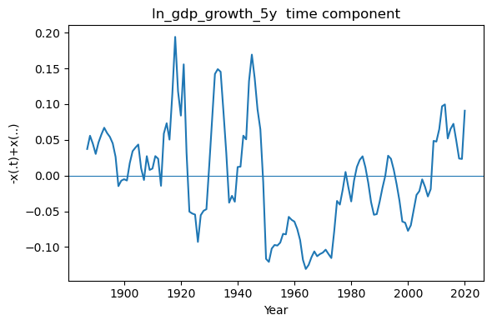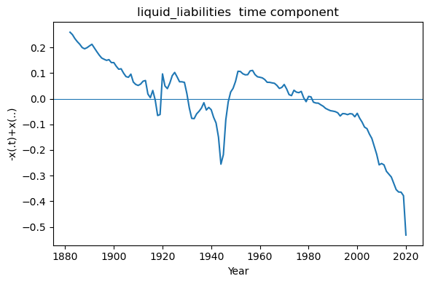

Log 5 year gdp growth fluctuates around zero for most of the sample but displays several pronounced positive spikes. These occur during major global recovery episodes, most notably in the late First World War and immediate post-war period (approximately 1917-1921), during the early 1930s rebound following the Great Depression, in the immediate aftermath of the Second World War (mid-1940s), and again during the post-Global Financial Crisis recovery (2009–2013). Conversely, the series becomes strongly negative during the 1950s-1970s, as well as during various subsequent global slowdown episodes. The difference measures how each year’s cross-country average deviates from the overall sample mean, positive values indicate years in which average growth across the 16 balanced-panel countries was above the long-run mean, while negative values reflect below-average growth years. Overall, the time component captures common global growth shocks, such as wars, crises, and post-war expansions, that affect all countries simultaneously.

The time component for liquid liabilities begins at a strongly positive value (approximately 0.25) in the late 19th century and declines monotonically over time, crossing zero around the mid-20th century and becoming increasingly negative thereafter, reaching levels below −0.5 by the end of the sample in 2020. Because the time component is essentially a difference of the means, as a downward-sloping trajectory indicates that the time-specific mean is rising relative to the overall mean of the series. This implies that liquid liabilities exhibit a persistent upward trend across all countries in the balanced panel. Early years are characterised by liquidity levels well below the long-run average, whereas in later decades, (particularly after 2000) the cross-country average exceeds the sample mean. This pattern is consistent with long-run financial deepening and the structural expansion of financial systems over the period studied.

To isolate the within-variation relevant for identification, both of my key variables were transformed using the standard two-way fixed effects (TWFE) procedure, removing all country fixed effects and all year fixed effects. After applying the TWFE transformation, the resulting variables should, by construction, have means extremely close to zero within each country and within each year. Table 11 provides diagnostic evidence that the transformation behaved exactly as expected.

Panel (b) shows that the mean by year is essentially zero for every year (on the order of 10⁻¹⁶), and Panel (c) confirms the same pattern for the mean by country. Likewise, the overall means in Panel (a) are numerically indistinguishable from zero. These results verify that the TWFE procedure successfully removed all time-invariant country components and common year shocks, leaving only the variation that identifies the regression coefficients.

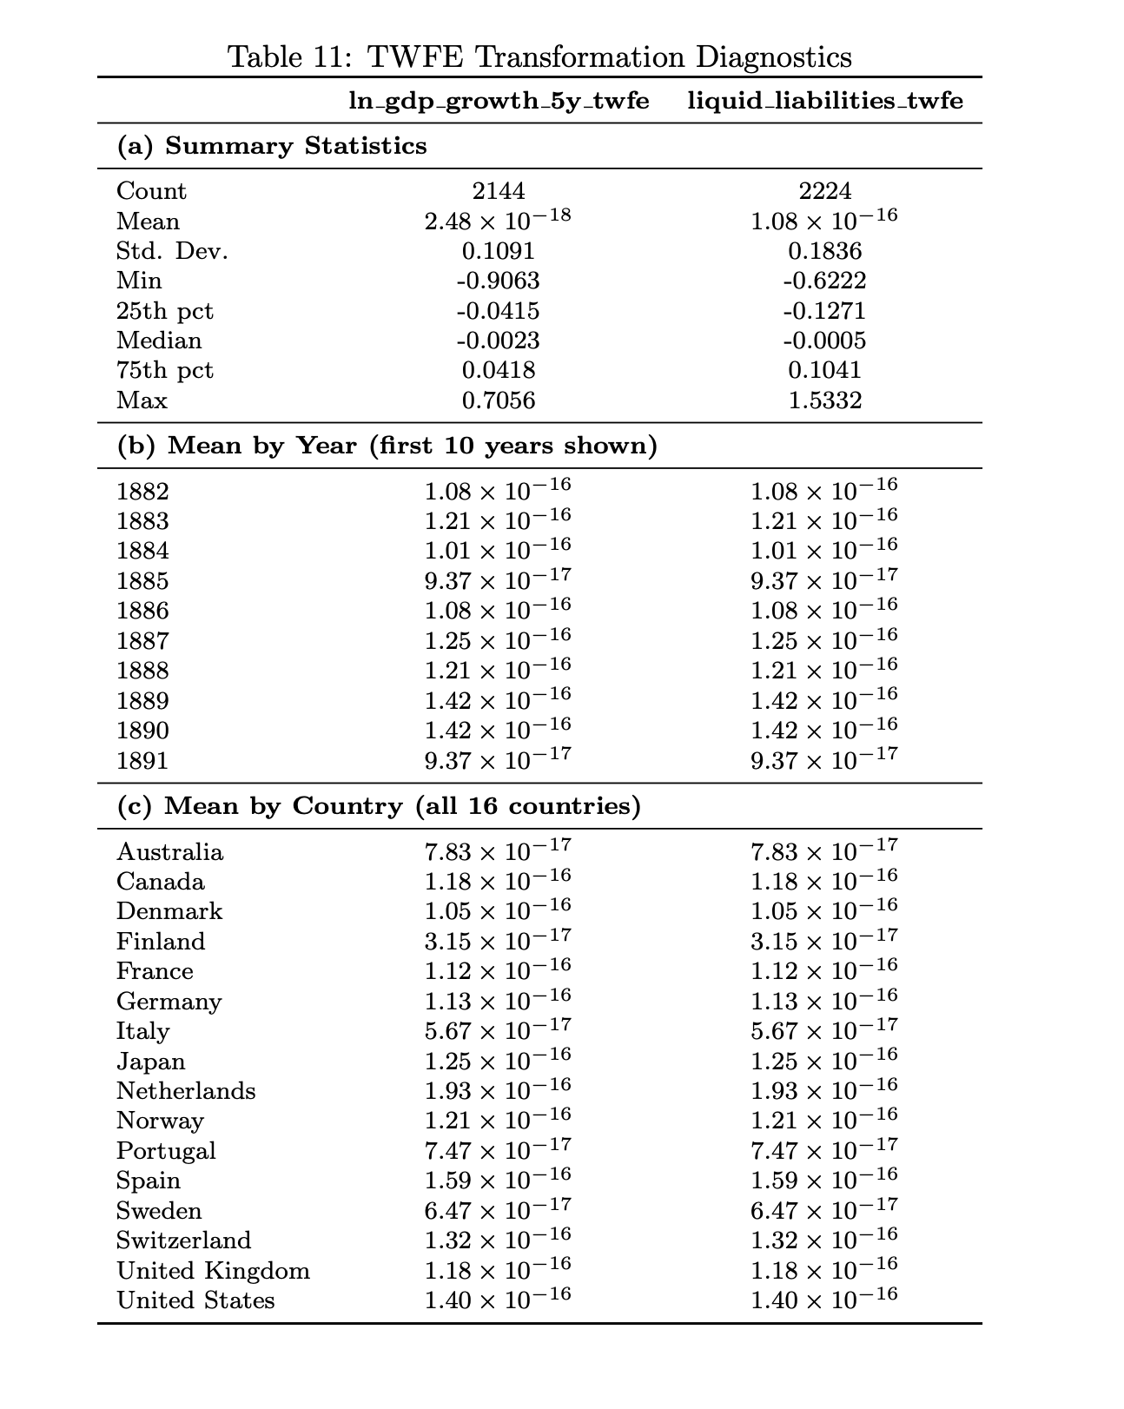

Question 10
TWFE Balanced panel. Compute descriptive statistics. Plot boxplots by country ordered by their variance from the smallest to the largest.

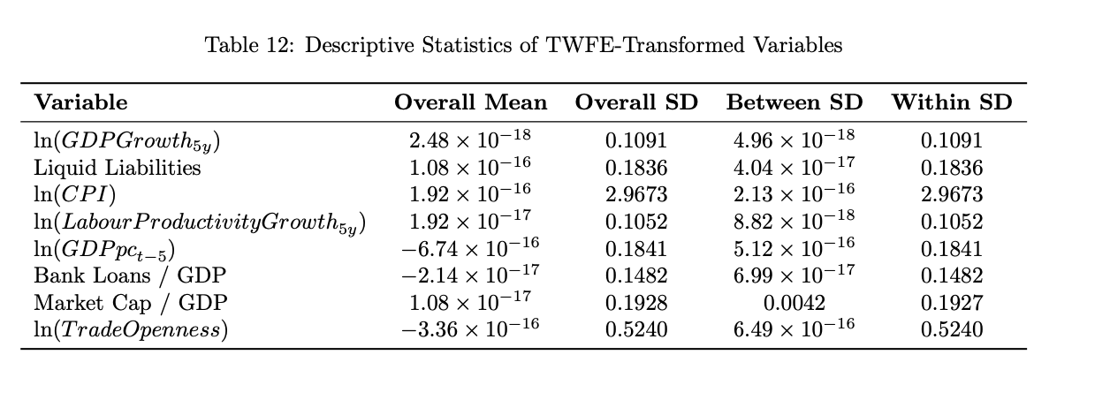

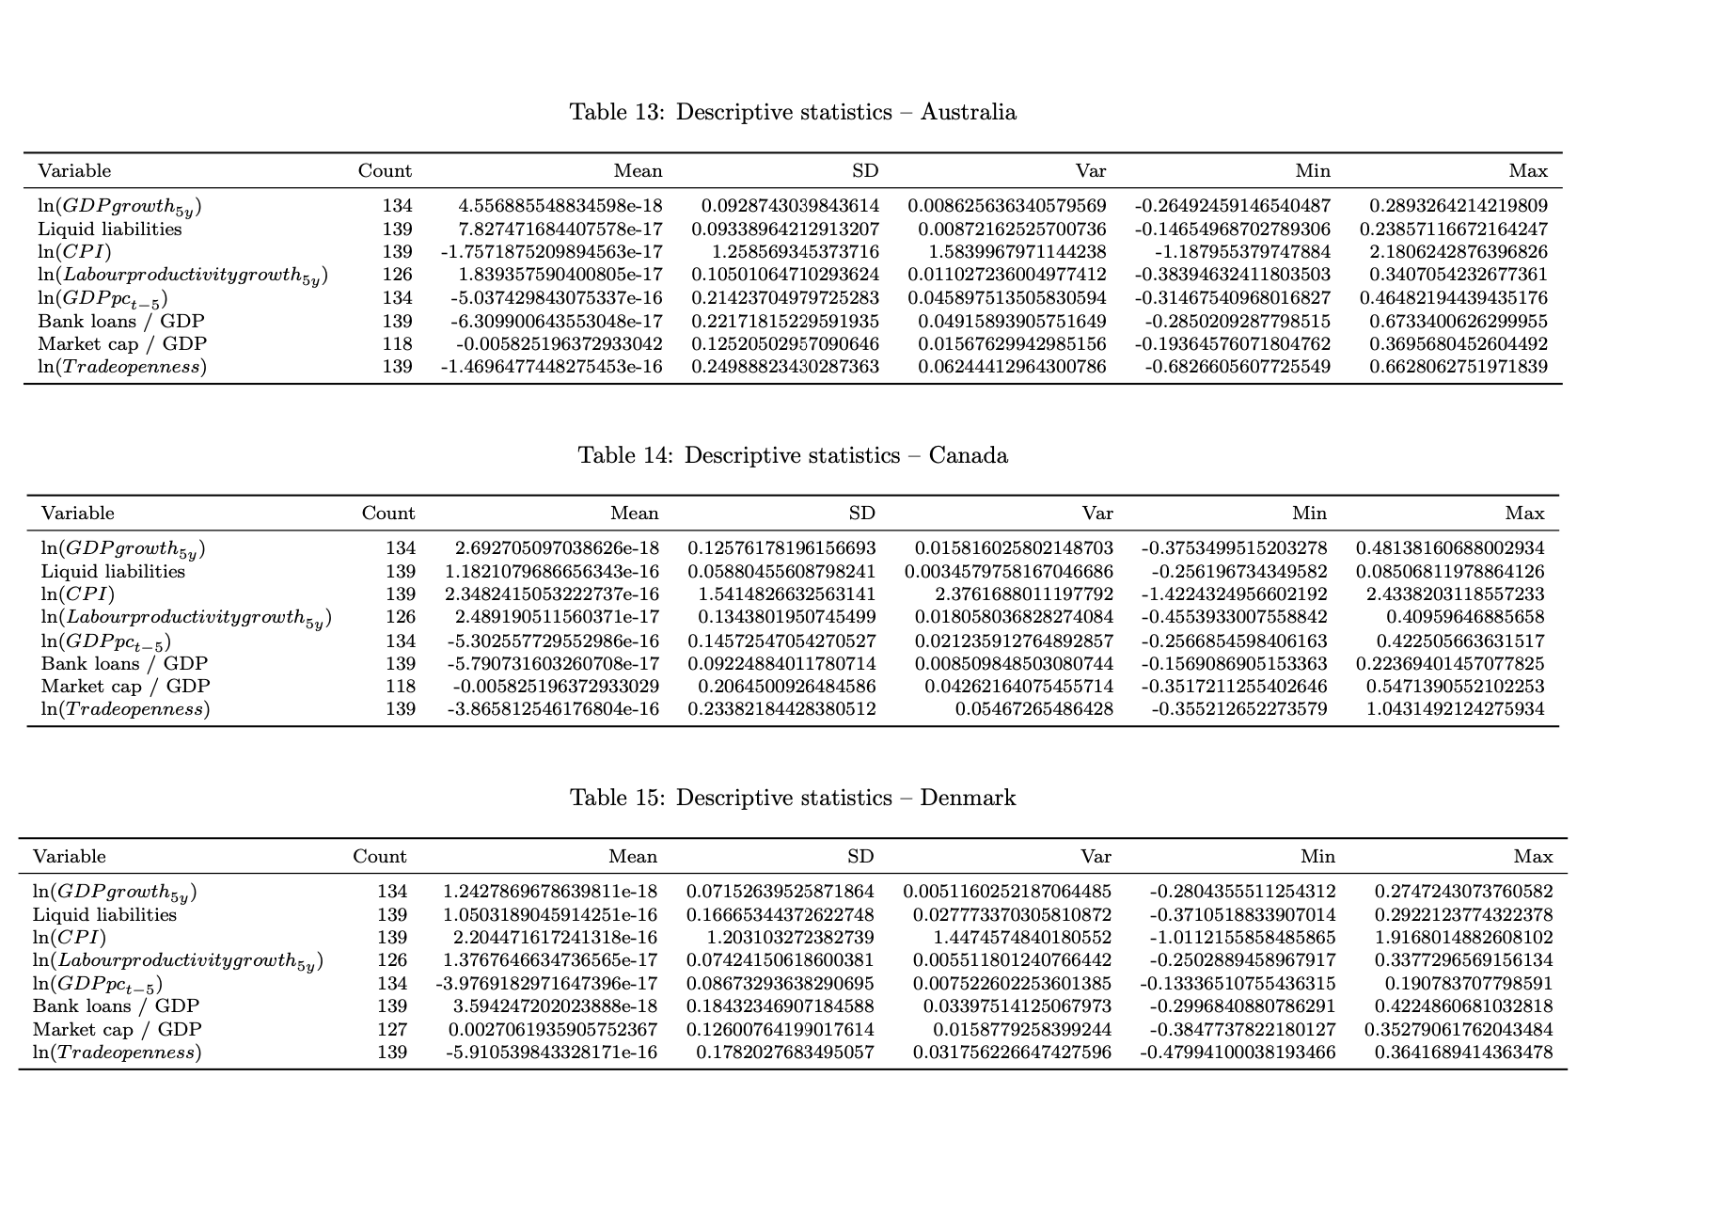

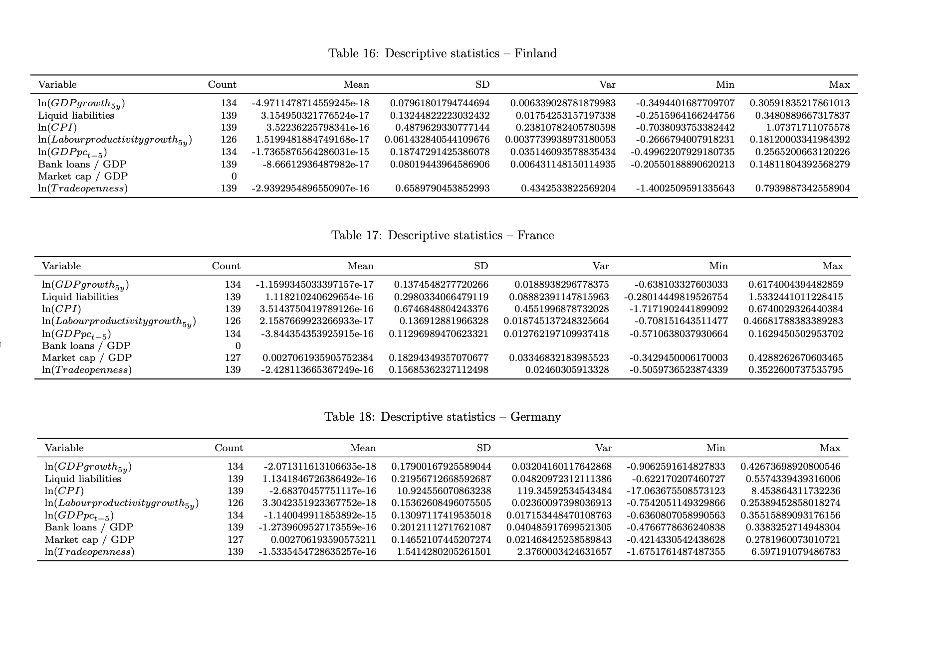

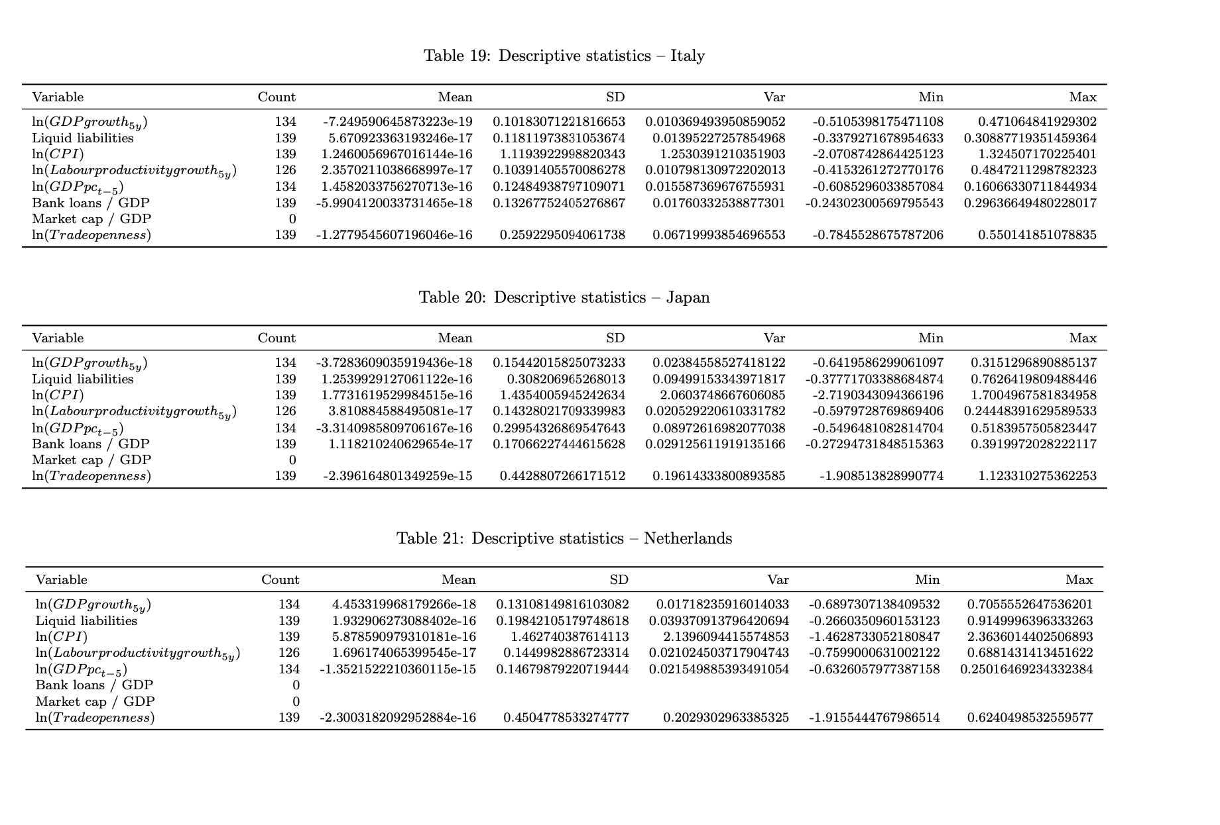

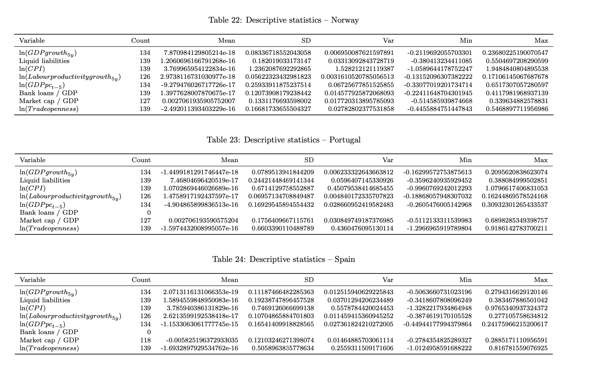

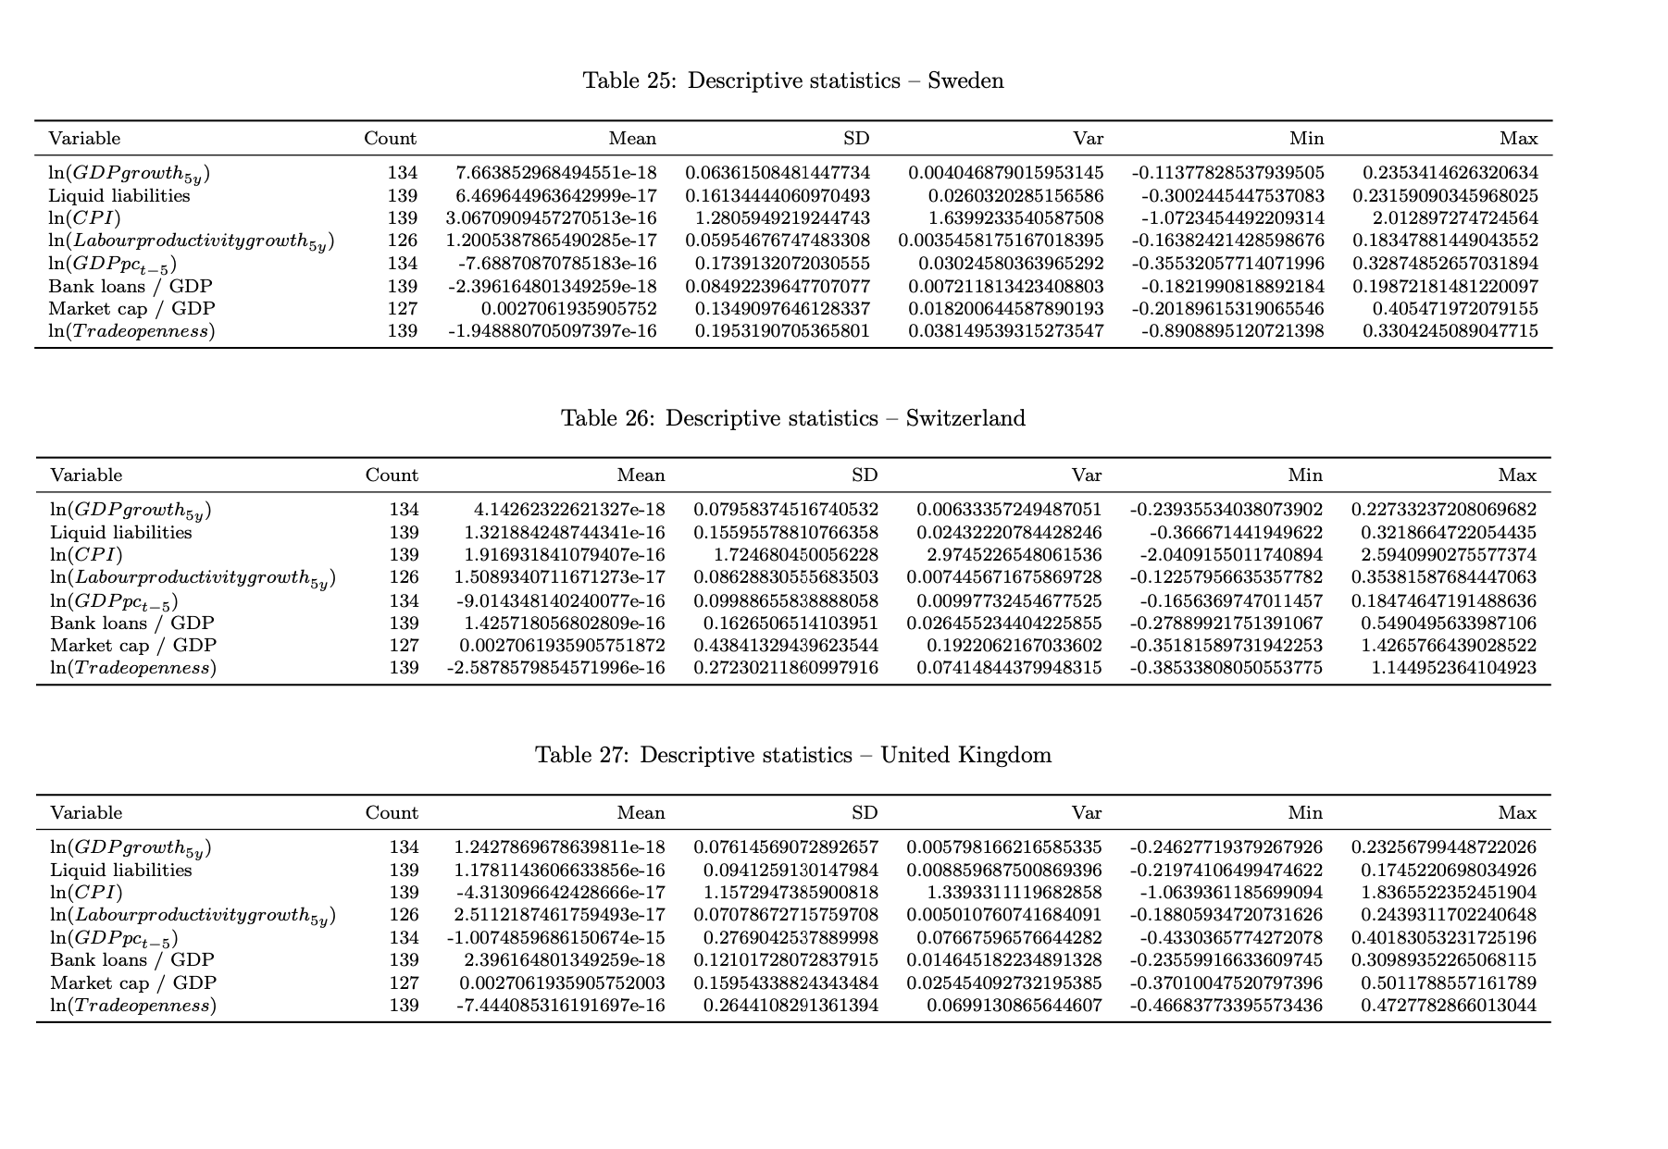
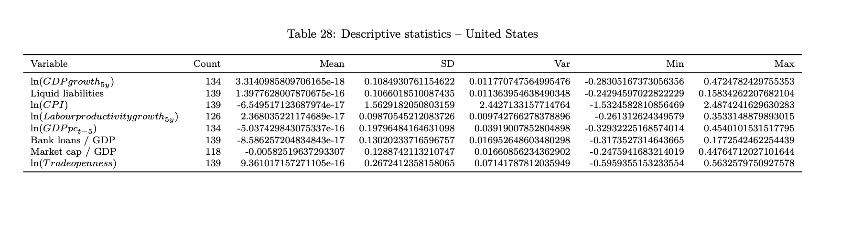
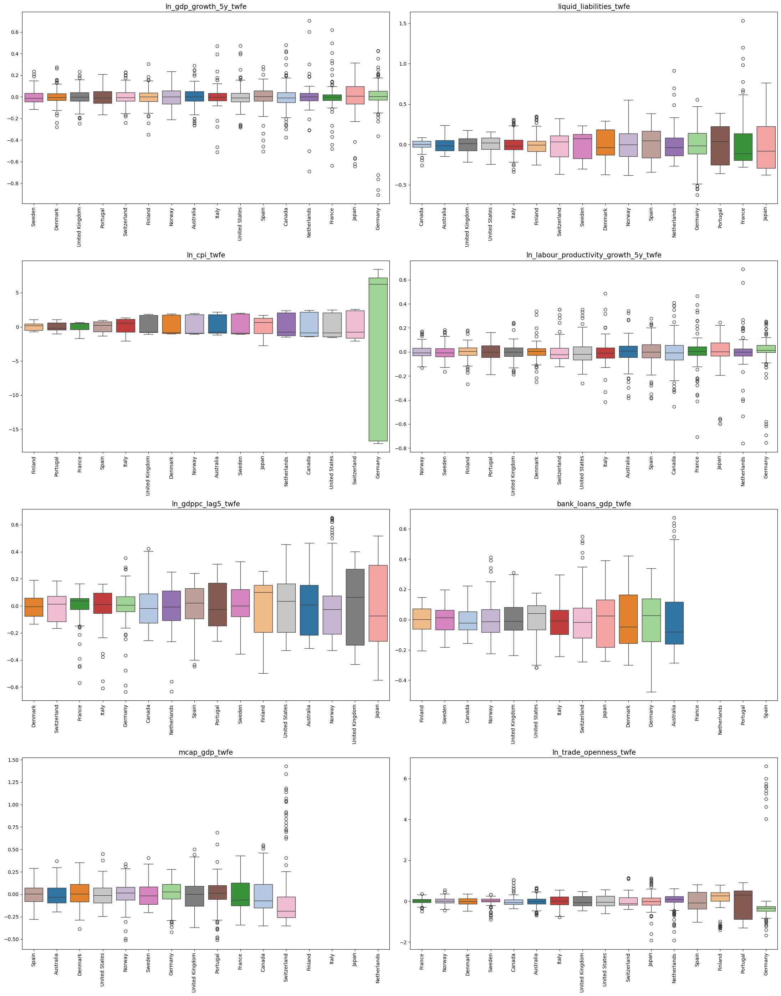

Question 11
TWFE Balanced panel. Present a table ordering the simple correlation coefficients of TWFE transformed GDPG and EDA/GDP by country from the largest positive to the lowest negative, with the standard error of GDPG and EDA in another column and the coefficient of simple regression: correlation coefficient * standard error of GDPG / standard error of EDA/GDP. Comment.

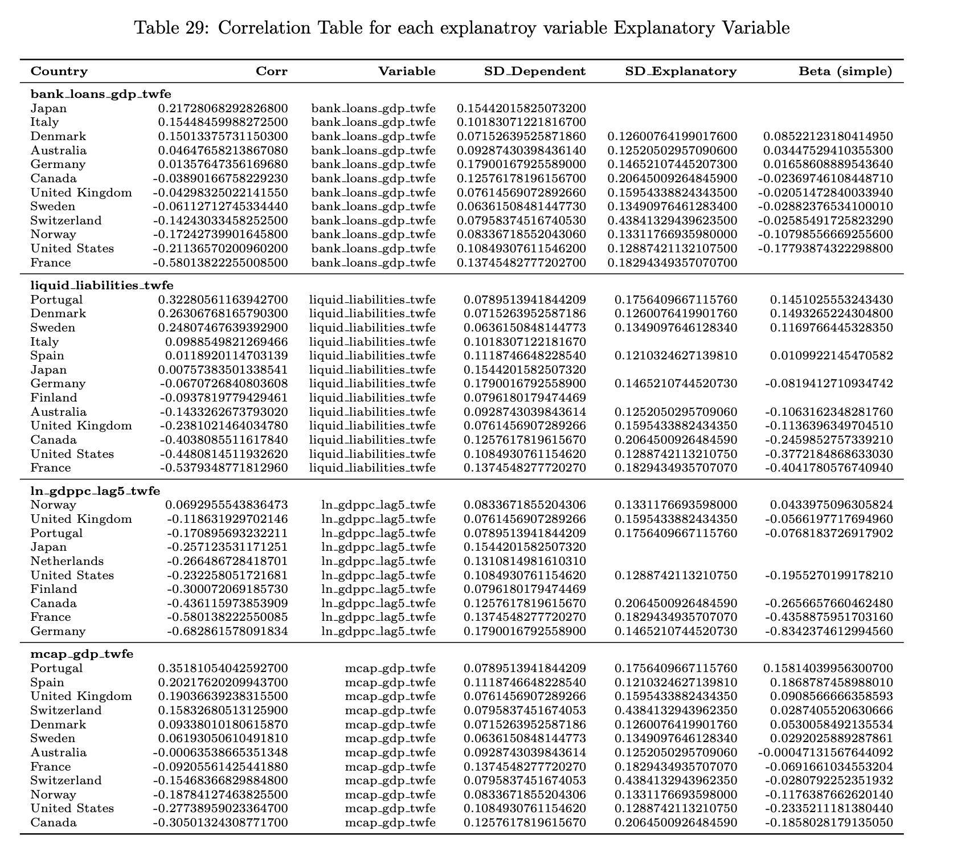

[comment on these]

Question 12
UNBALANCED PANEL and TWFE transformation (remove countries with a single observation). Regress within transformed GDPG on time dummies and collect the residuals: this is the TWFE transformation. Regress within transformed EDA/GDP on time dummies and collect the residuals: this is the TWFE transformation. Alternatively, code the Wansbeek Kapstein (1989) transformation for two way fixed effects resulting in their equation 2.13 which is an extension of x(it)-x(i.)-x(.t)+x(..) obtained in the balanced panel case.

Question 13
TWFE unbalanced panel: plot the distribution (Kernel DE, histogram, corresponding normal law with the same two first moments). for dependent GDPG and explanatory EDA/GDP. Compare with one-way-fixed effects, between distributions.

Question 14
Plot boxplots of between distribution (all countries), then one-way and two-way-fixed effects and first differences distribution BY countries (or 20 individuals if your data set has more than 20 individuals), for the dependent variable and the key explanatory variables. Comment that you find the same insights from question 5. Comment on their differences of standard errors and means for each individuals

Question 15
Compute univariate descriptive statistics (min, Q1, median, Q3, max, mean, standard error) for one-way-Within, Between, two-way-fixed-effects and first differences transformed variables. Is the mean different from the median and why? How many standard errors from the mean are the MIN and MAX extremes. Report in the tables standardized MAX and MIN: (MAX-average)/standard error and (MIN-average)/standard error instead of MAX and MIN?

Question 16
Compare and comment the between versus one-way-within transformed bivariate correlation matrix for all variables (include a time trend 1,2,.,T) and with their lag (for time varying variables). Check poor simple correlation with the dependent variables and high correlation between explanatory variables.

Question 17
Comment the bivariate auto-correlation and trend-correlations (check the number of observations).

Question 18
In what follows, you do not need to include a deterministic time trend 1,2,.,T because the two transformations used eliminate it. Compare and comment of the two-way-within transformed bivariate simple correlation matrix of all the variables and another bivariate simple correlation matrix with all the first differences transformed variables (in the case of first differences, include also the lag of all variables). Check poor simple correlation below 0.1 with the dependent variables and high correlation between explanatory variables (over 0.8). Show the first 30 observations for the first differences and the lag of first differences. Check that each time you change individual, you have a dot for missing observation.

Question 19
Comment the bivariate graphs with linear, quadratic and Lowess fit for dependent and key explanatory variable (growth of gdp/head on vertical axis and aid/gdp): Within transformed, Between transformed, First differences, two-way-within transformed.

PART 2: Classic benchmark multivariate panel data estimators

Question 20
In a single table, report and comment the results of estimations of Between, Within (one-way fixed effects, (fe)) and Mundlak (random effects (re) including all X(i.) as regressors), two-way fixed effects (add year dummies in fe regression) and First differences, including all explanatory variables except the ones with high near-multicollinearity after their transformation.

Question 21
If, for the first differences dependent variable, it remains a simple auto-correlation above 0.1, a dynamic panel estimator can be tried. The estimators of the generalized method of moments (GMM) for panel data are only valid for short time panel T<10 and they face the issue of too many weak instruments. We suggest using its precursor, the Anderson-Hsiao (1981) estimator which allows to check the first stage of instrumental variables and to test for weak lagged instruments. Estimate an auto-regressive distributed lag (ARDL) model for dynamic panel data including the first lag of the dependent variable (for example: GDP per head growth) and the first lag of the key explanatory variable (for example: foreign aid/GDP), adding the first lag of other control variables is optional:
Δ GDPG_{i,t} = β_{y} Δ GDPG_{i,t-1} + β₁ Δ (aid/GDP)_{i,t} + β₂ Δ (aid/GDP)_{i,t-1} + Δ Controls _{i,t} + Δ α_{i} + Δ α_{t} + Δ ε_{i}
- For all these variables: ΔGDPG_{i,t} Δ GDPG_{i,t-1} Δ (aid/GDP)_{i,t} Δ(aid/GDP)_{i,t-1} GDPG_{i,t-2} (aid/GDP)_{i,t-2} report univariate statistics (mean median standard error, skewness, kurtosis, min max) and comment.
- Report the bivariate simple correlation coefficients matrix. The correlation between Δ GDPG_{i,t-1} Δ (aid/GDP)_{i,t} Δ (aid/GDP)_{i,t-1} and the instruments in levels: GDPG_{i,t-2} (aid/GDP)_{i,t-2} is a preliminary check for the strength of these instruments.
- Do a panel data unit root test of your choice on the variables ΔGDPG_{i,t} and Δ(aid/GDP)_{i,t} and comment.
- Report the OLS including the lag of the first difference of GDPG and of other explanatory variables. Report the number of observations and the number of countries remaining in the estimation, which requires at least three consecutive observations for each country.
- Report the IV estimator (IVREG) when you use the instruments in levels GDPG_{i,t-2} and (aid/GDP)_{i,t-2} . Comment how much each parameter changes when using OLS versus IV.
- Report the first stage regressions. Comment the R2 of each of the first stage regressions, if below 10%, it is a signal of weak instrument. You may comment statistics available in your software for weak instruments and for testing endogeneity of instruments.
- Compute and plot the impulse response functions for the next four periods for 1 unit increase of aid/GDP on GDPG:
t=1: β₁
t=2: β_{y} β₁ + β₂
t=3: β_{y} ² β₁ + β_{y}β₂
t=4: β_{y} ³ β₁ + β_{y} ² β₂
- Compute the long run coefficient of key explanatory variable on the dependent variable and comment:
β_{LT} = ( β₁ + β₂) / (1 - β_{y} )

PART 3: Open section

Question 22
Do whatever seem interesting to you in terms of original estimations (not already done by the replication of the original authors) with this database, present the table(s) in this file with comments, not only in the html output with code and output.

PART 4: To do list

Question 23
Fill in a TO DO list for the next time you will do a study involving panel data, in particular for your master thesis (see next page). This can be done jointly by pairs of students of option 1.

PART 5: Translation of code.
Upload the translation of code with the help of LLM: upload at least one code that works in STATA and at least one code that works in R or Python (that is two codes at least).

An ordered to do list for your next econometric study using panel data.
You may split the table into several tables for each step: data selection, variable transformations, descriptive statistics tables and visualization, estimators and endogeneity, sample splits and robustness checks… The numbers of items are unlimited.

Tick | Items

Australia, Canada, Denmark, Finland, France, Germany, Italy, Japan, Netherlands, Norway, Portugal, Spain, Sweden, Switzerland, the United Kingdom, and the United States

